**Mentor PADS**

Install **Teamcenter EDA**

Install **Strawberry Perl**

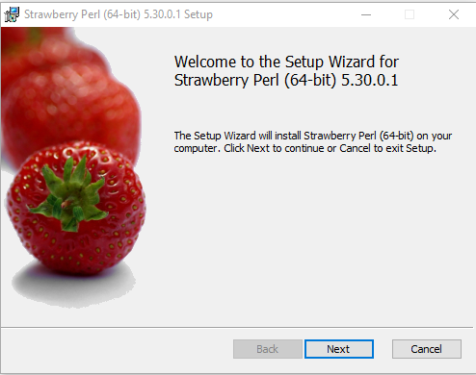

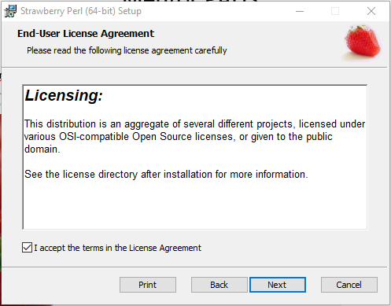

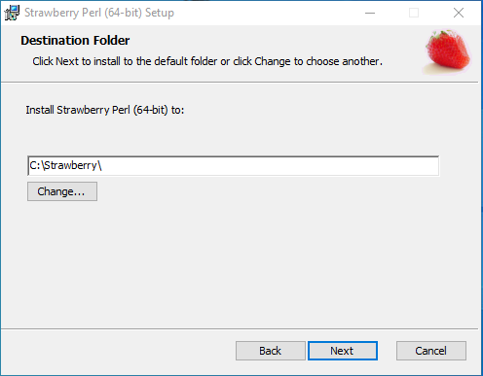

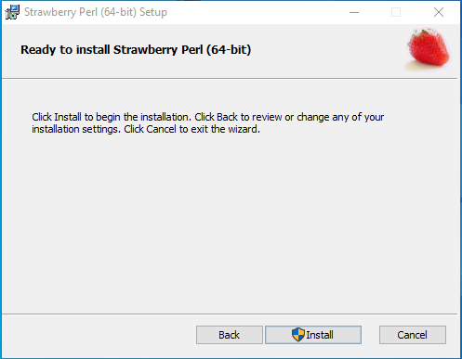

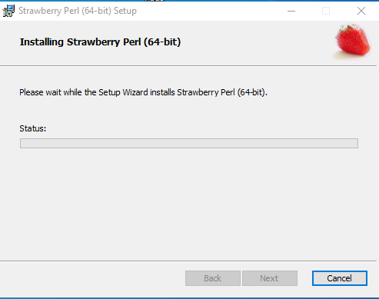

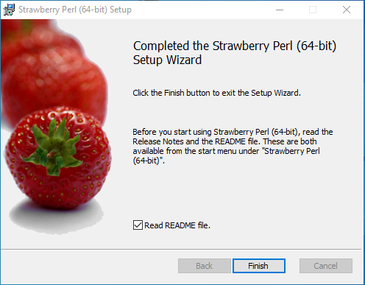

Set **SDD_HOME, TCEDA_JAVA_HOME** and **TCEDAECAD_ROOT** in **User variables for Administrator**

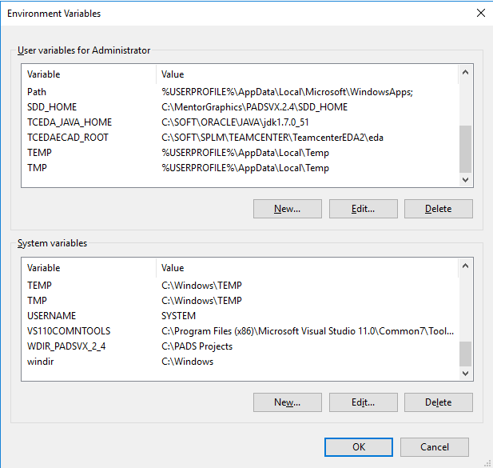

Open file in **C:\SOFT\SPLM\TEAMCENTER\TeamcenterEDA2\eda\TCEDAClient.properties**

Do the following changes in **TCEDAClient.properties** file.

Change the URL according to your settings.

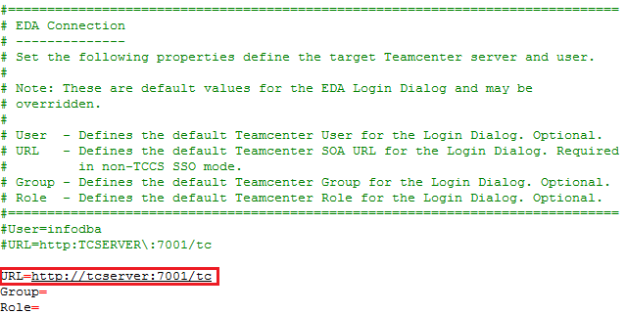

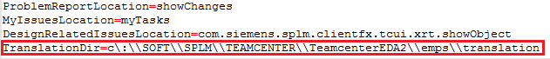

Open file in **C:\SOFT\SPLM\TEAMCENTER\TC_ROOT\portal\plugins\configuration_11000.2.0\client_specific.properties**

Do the following changes in **client_specific.properties** file.

**PortalViewer_Optional_Licenses=Simplified,Rendering,ECAD,Concept_Desktop,Collaboration,Visual_Report**

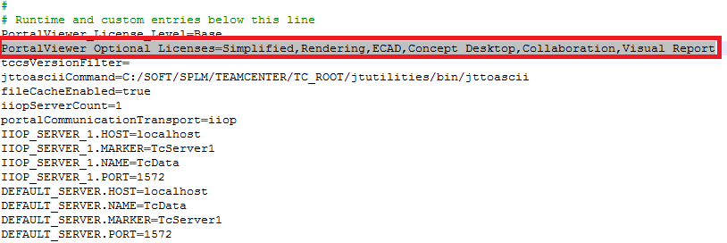

**Library Management in Mentor PADS**

Run **tem.bat** from installed eda location

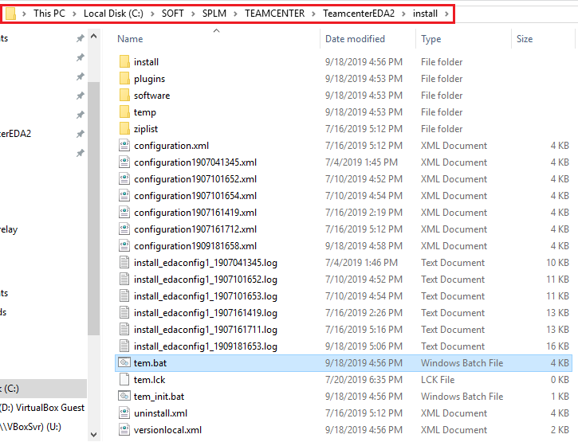

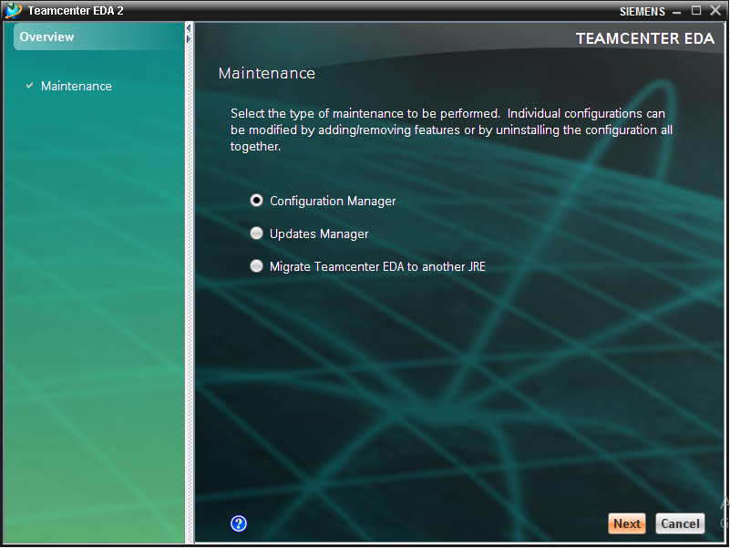

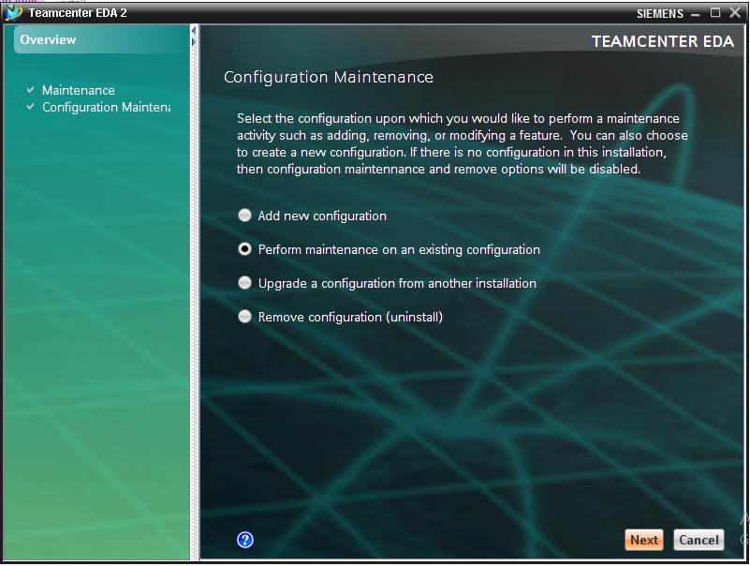

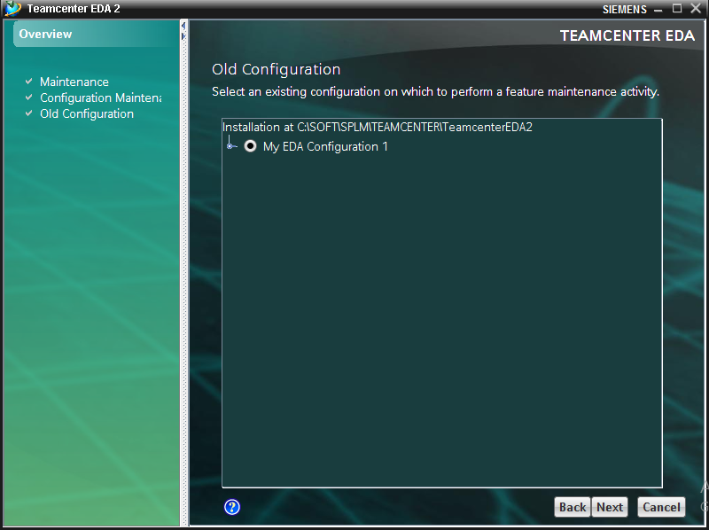

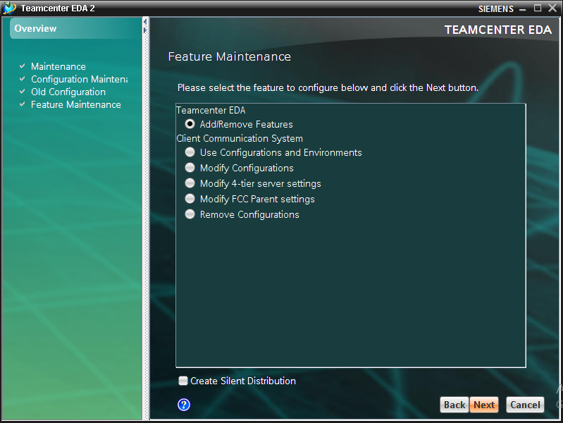

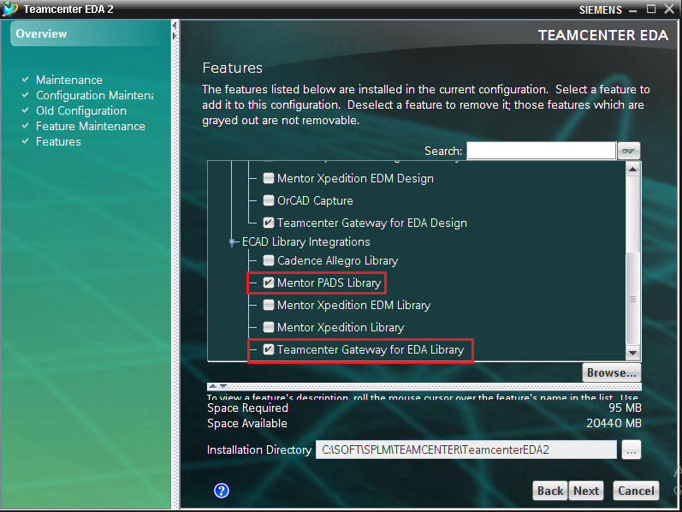

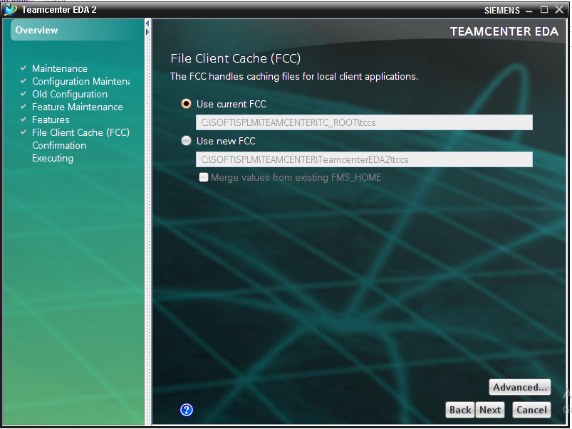

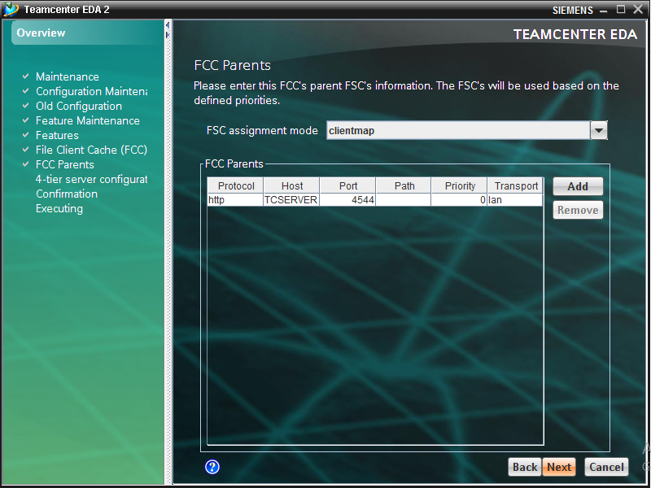

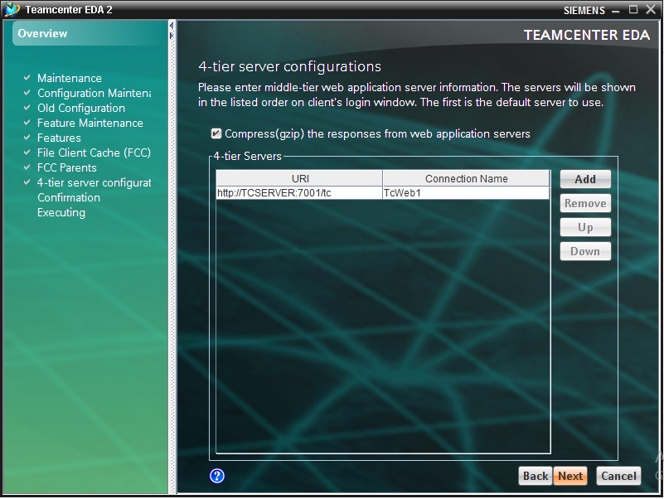

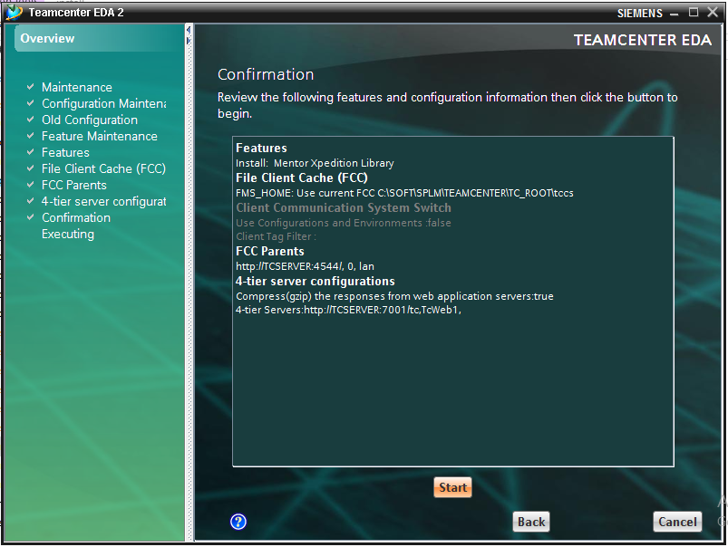

Run **PADS Layout VX.2.4** from start menu.

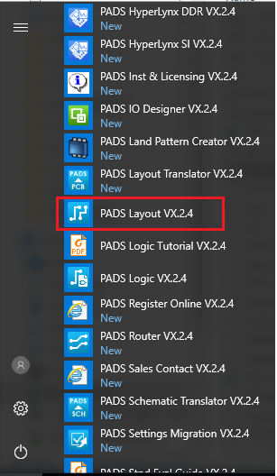

Go to **File -> Library…**

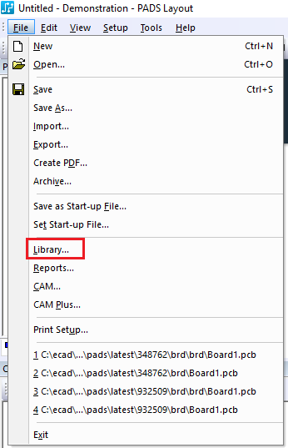

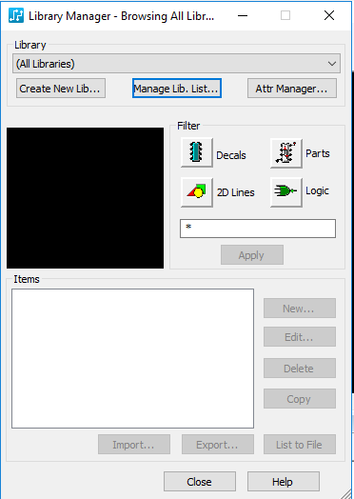

Select **Manage Lib. List…**

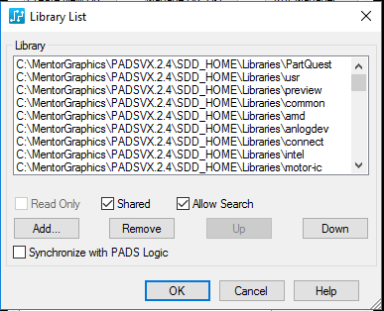

Select **Add…**

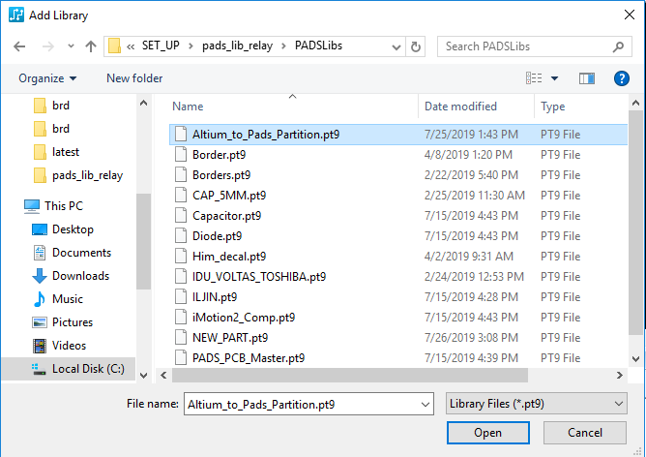

Select library file.

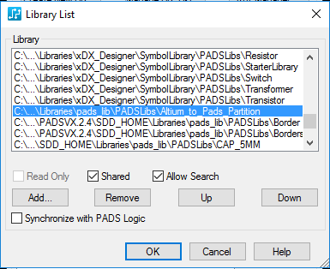

Selected library file will get added click OK.

Open **Organization** application in Teamcenter.

Create **External Applications**.

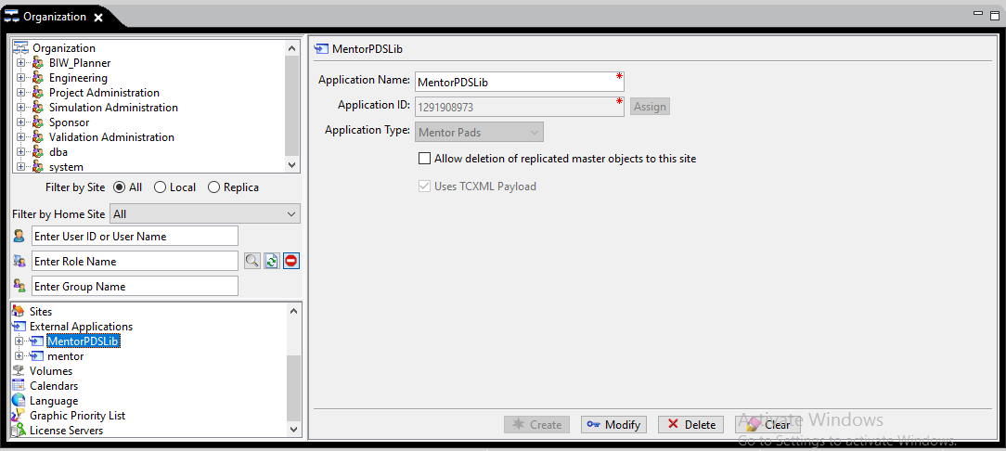

Run **pool_manager** and **jboss** services are mandatory.

Run **eda_gateway.bat** from eda location.

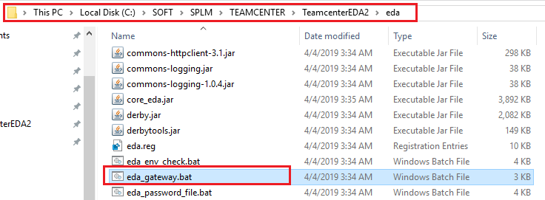

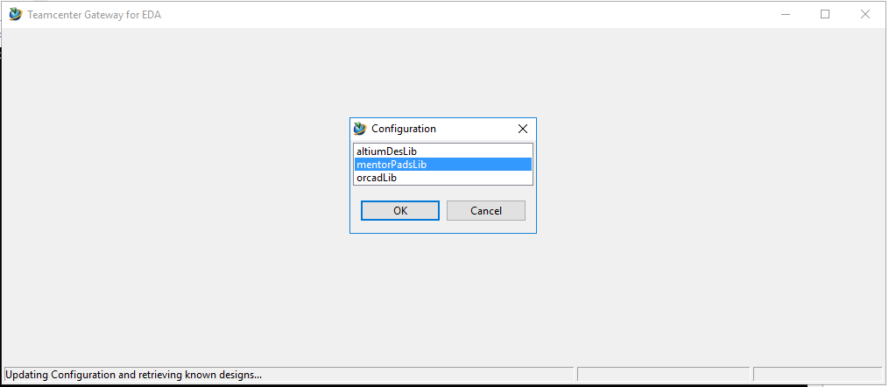

Select **mentorPadsLib** from options

Login with teamcenter account credentials.

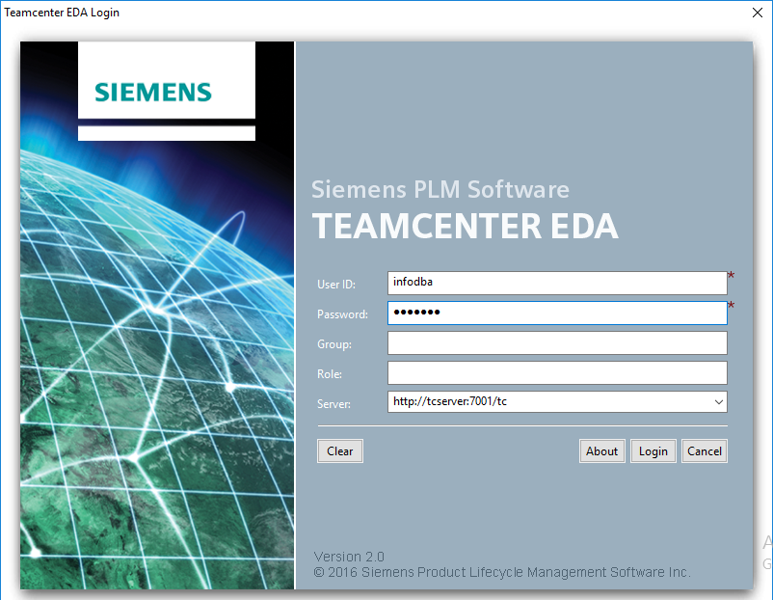

Go to **Teamcenter -> Configure**

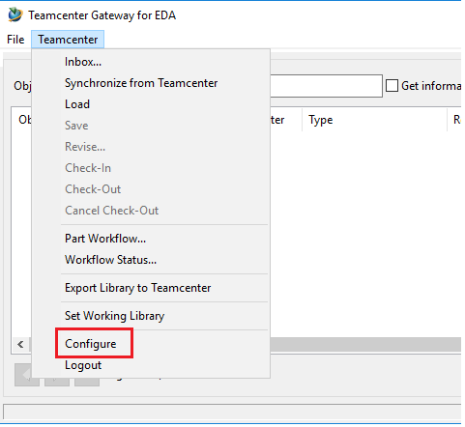

Give **Library Configuration**

**Teamcenter Part Library** it should be same as **External Application** you created in **Teamcenter Organisation**

**Browse…** and select library which you have added earlier in PADS Layout.

Click on Apply and OK.

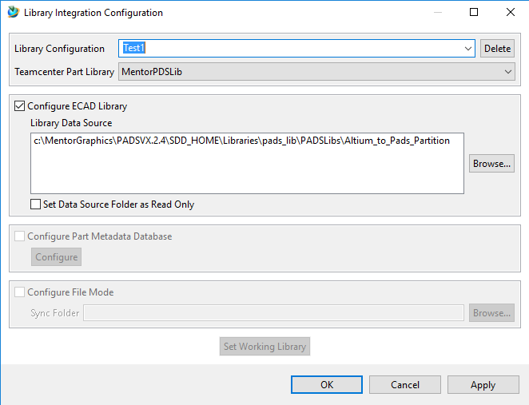

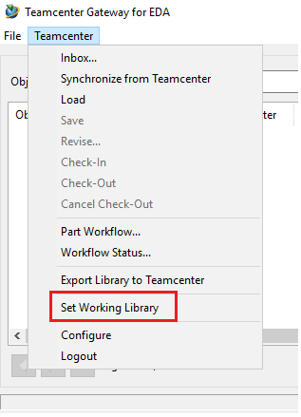

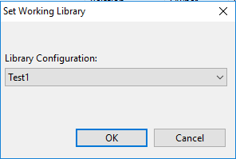

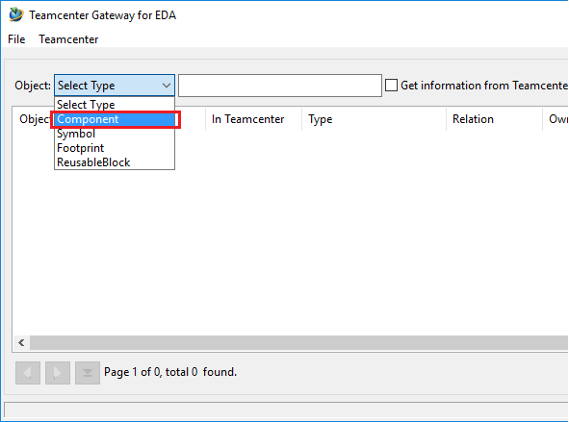

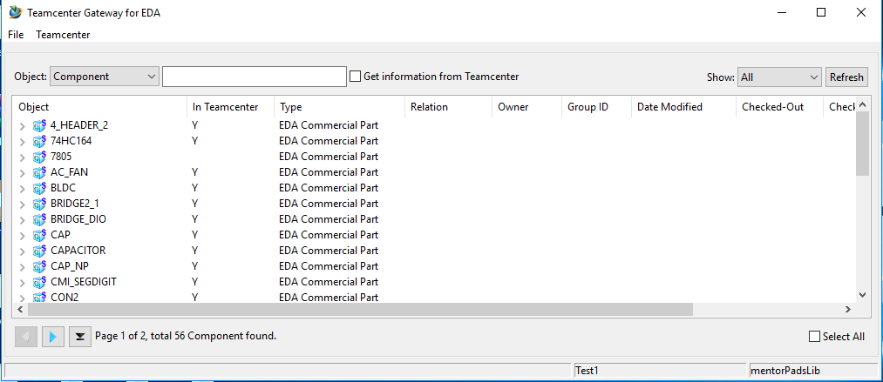

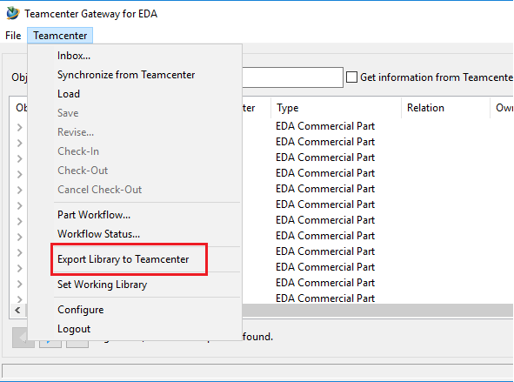

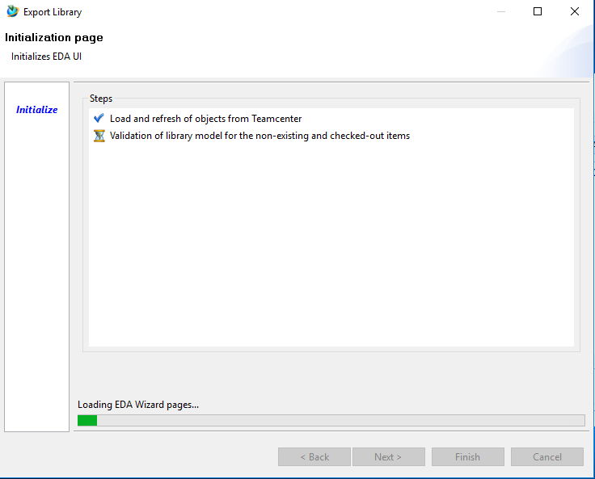

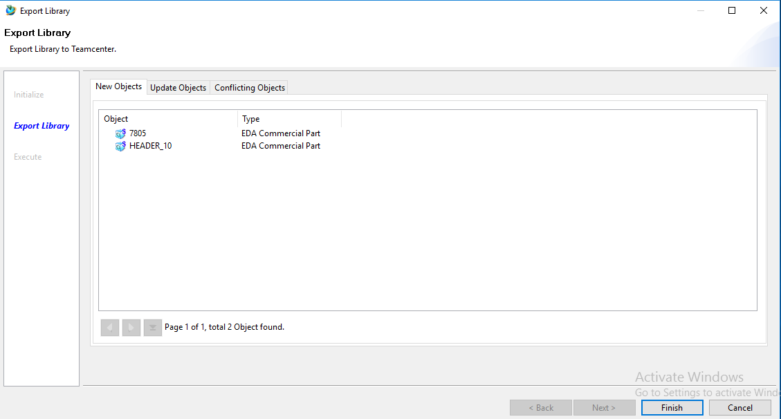

Click **Finish**

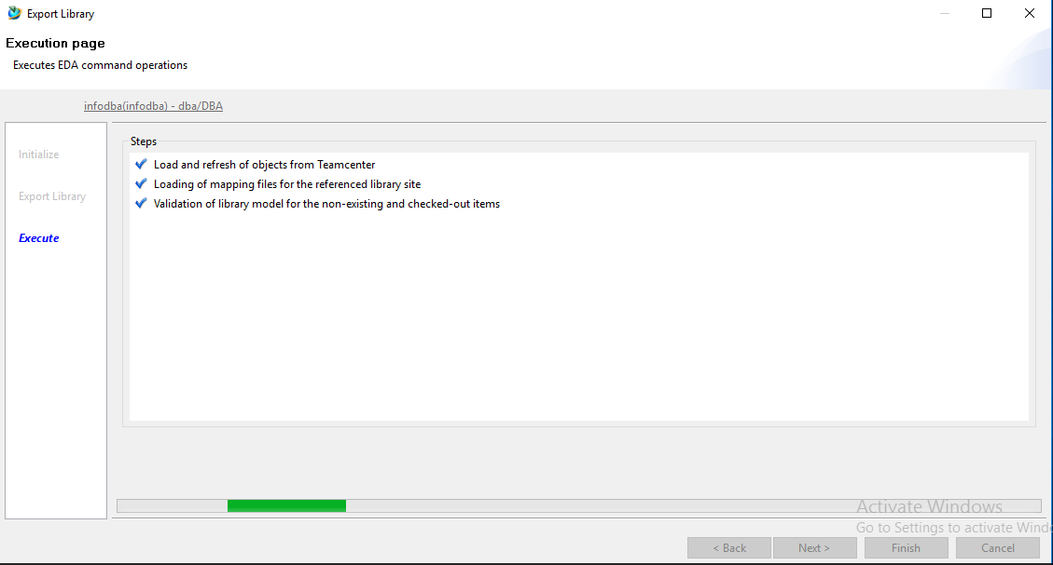

**Save Operation in Mentor**

Run **pool_manager** and **jboss** services before running scripts.

Create a folder in given location give number create brd folder inside it copy all data (as shown in image).

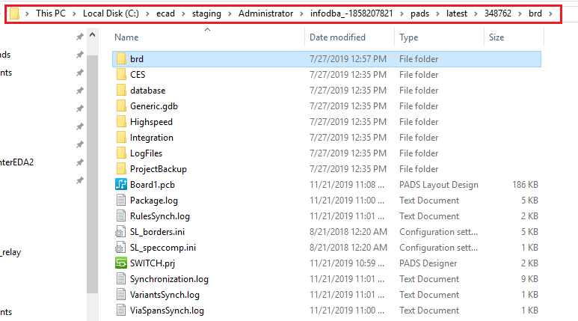

Run **mti_pads_logic.bat** script to Open Pads Designer

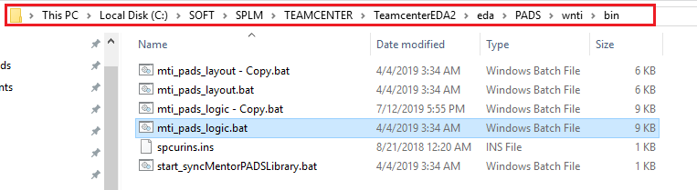

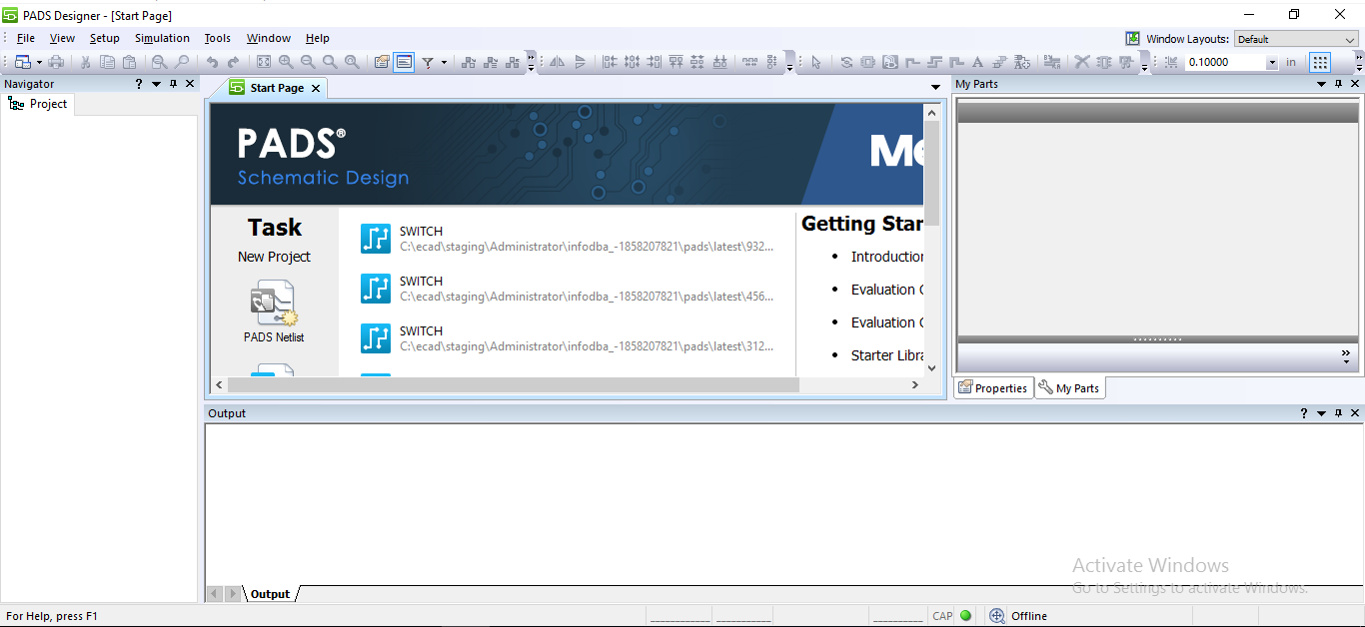

Go to **File -> Open -> Project…**

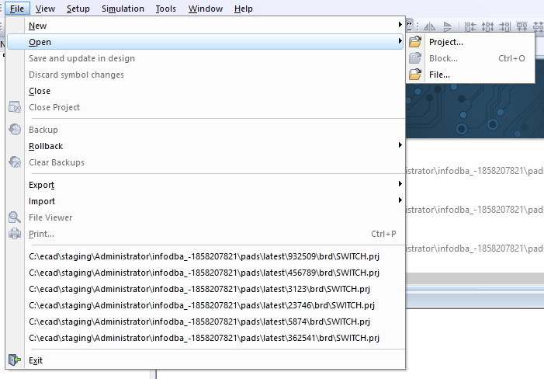

Select **.prj** file from previously created location and click open.

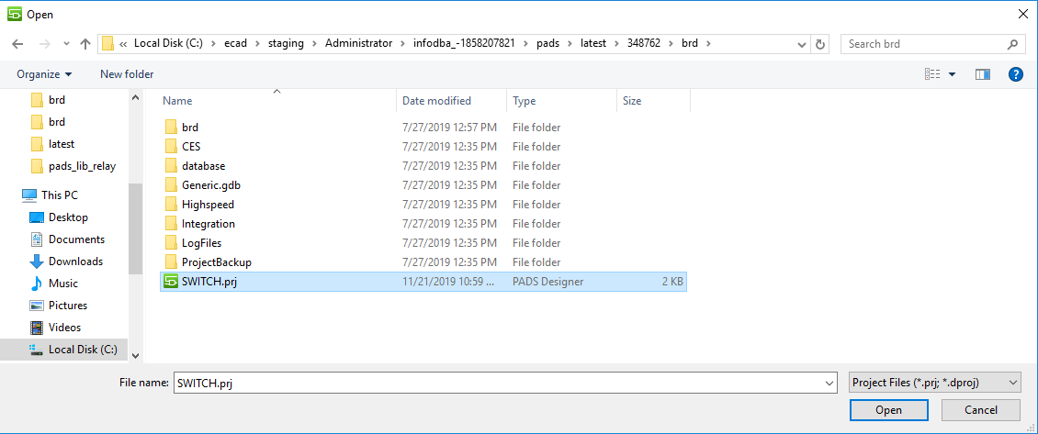

Set library path

Go to **Setup -> Settings…**

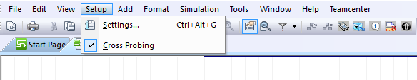

Give **Central Library Path** where your **.lmc** file is situated.

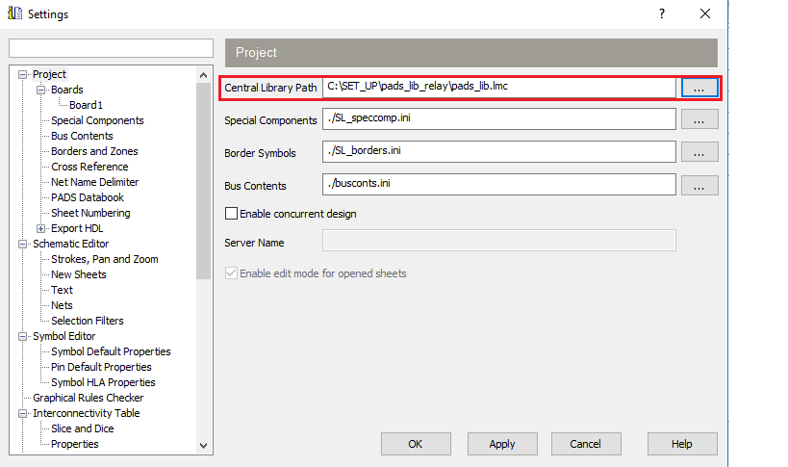

Open **PADS Layout**

Go to **Tools -> PADS Layout**

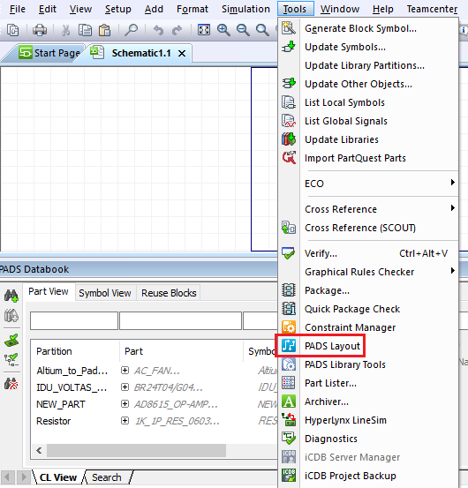

First locally save PCB file in previously created brd folder on system

Go to **File -> Save As…**

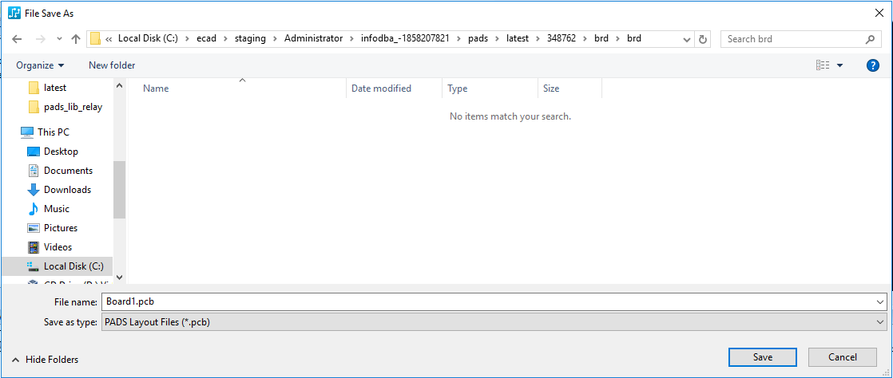

Save it in Teamcenter

Go to **Tools -> Basic Scripts -> Teamcenter**

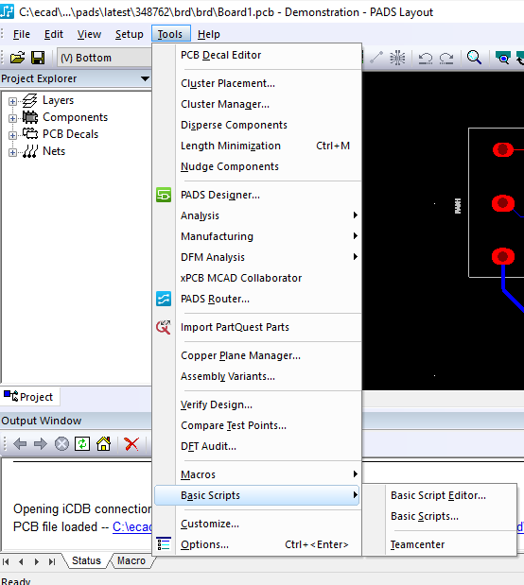

Select **Save As…** from newly opened window

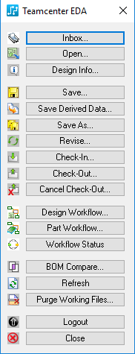

**Login with user credentials**

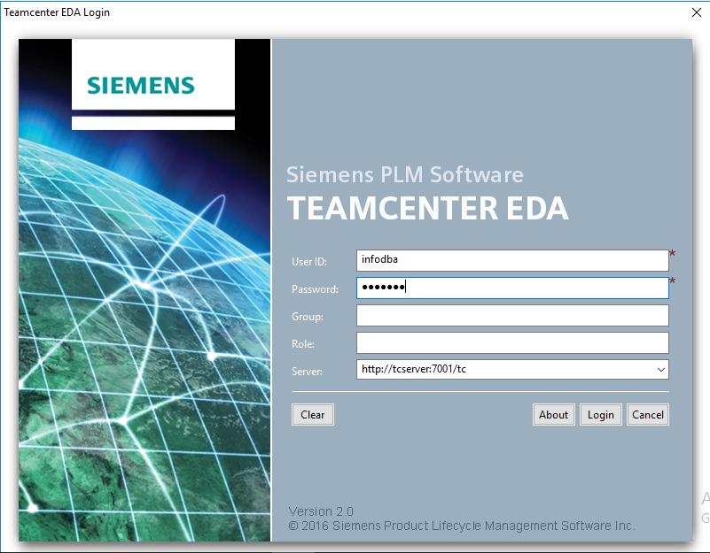

Select component which you want to save in teamcenter and click finish.

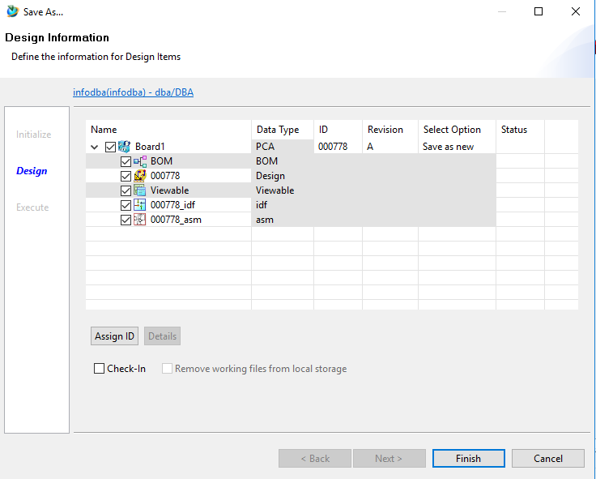

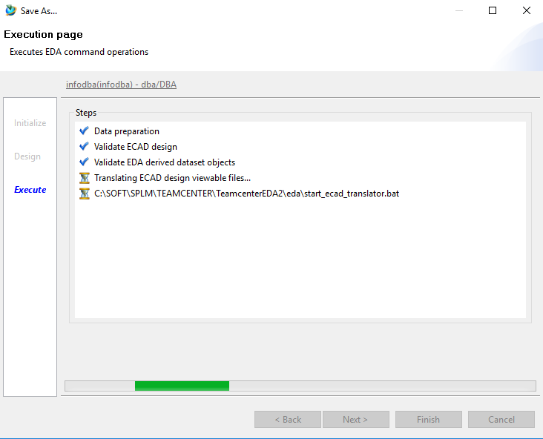

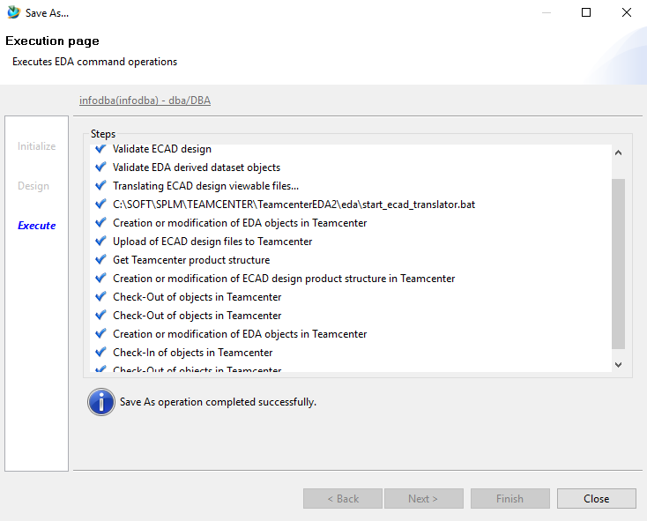

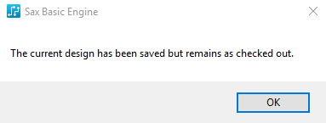

Select Check-In from Teamcenter menu window



Select objects to Check-In click finish.

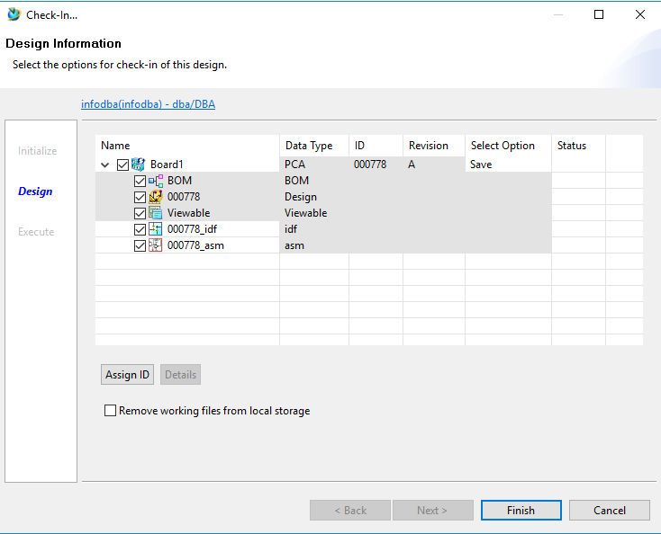

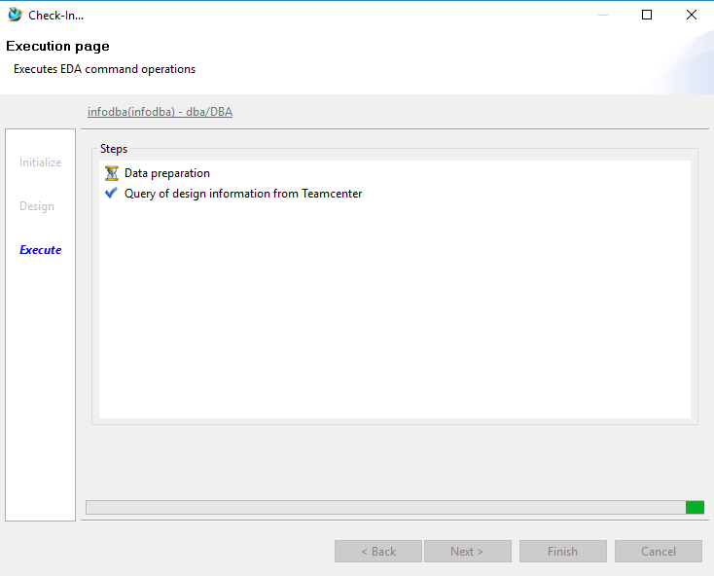

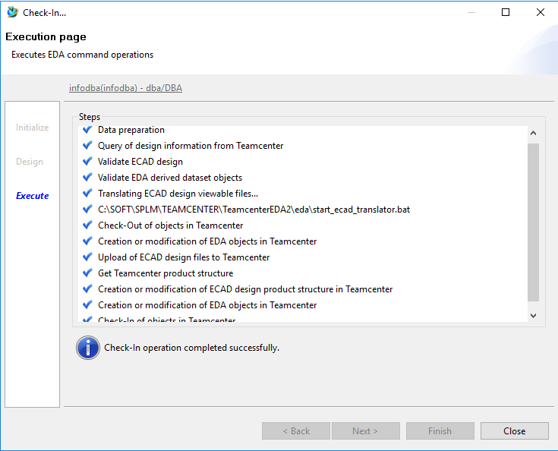

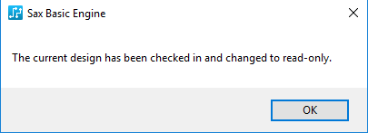

Save Schematic in Teamcenter

Go to PADS Designer

**Teamcenter -> Save As…**

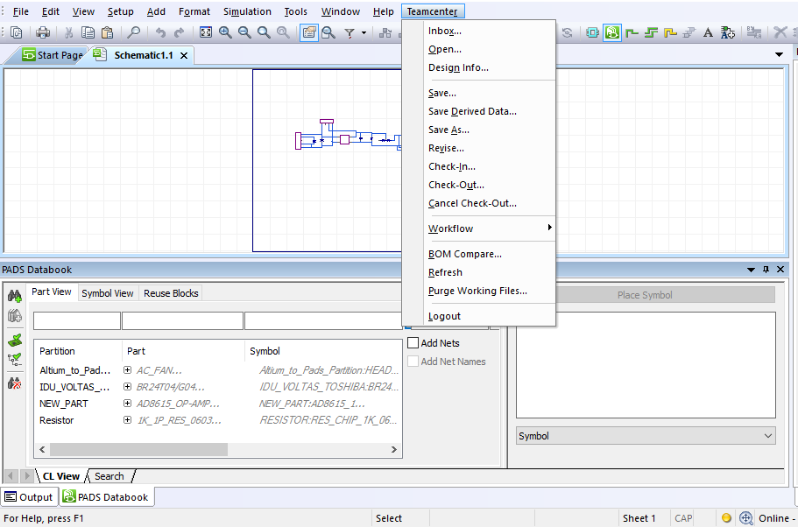

Unselect BOM object

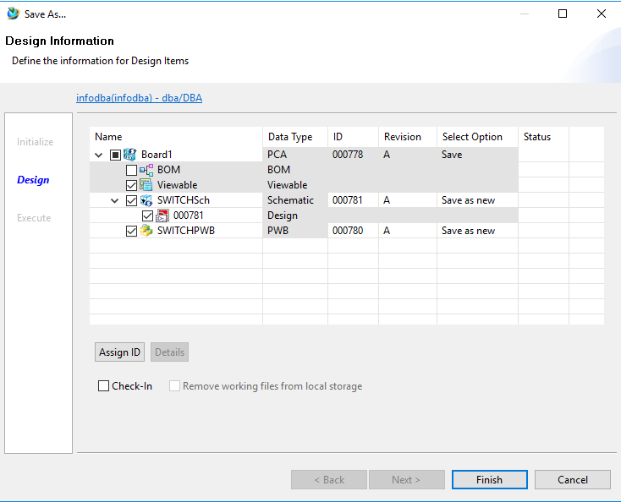

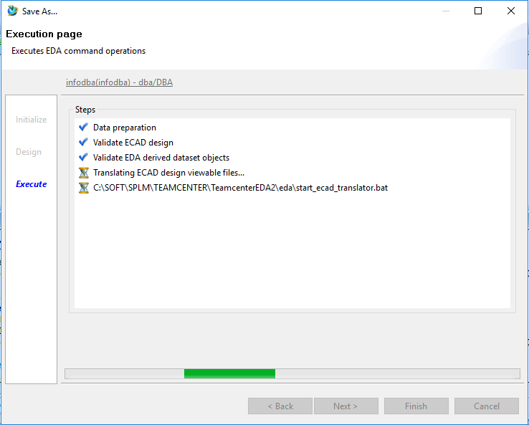

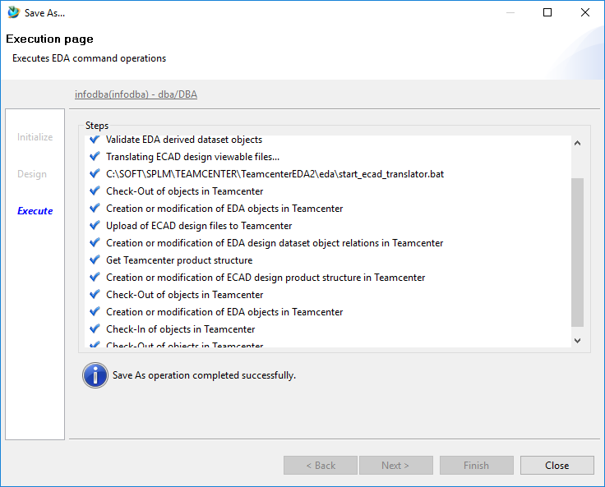

Login to Teamcenter Rich Client and see results.

